ART HISTORY Name: ___________________________
Quiz #1 – Ancient Near Eastern (50 points)
PART I: Civilization Identification (15 points)
Please fill-in the missing information on the chart below.
City-State | People | Area (N or S) | Visual | Ruler
Lagash | Sumerian
Babylon |  |  | Stele of Hammurabi
Persepolis | Persian
Uruk |  |  | The Warka Head
Akkad | Akkadian
For extra credit: fill-in the information for the missing group not found in the above chart. (2 ½ points)

PART II: Slide Identification (25 points)
Please fill-in the requested information for the following images.
Use the “MISC:” Box to substitute one answer; ie, don’t remember the date, give an alternative detail.
1)
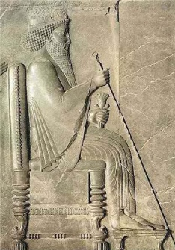 | Title:
 | Civilization:
 | Northern / Southern
 | Building:
 | Date:
 | Misc:

2)
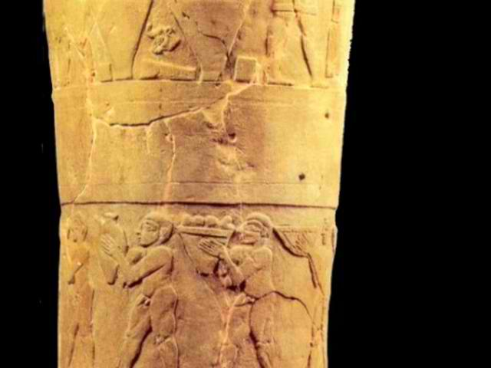 | Title:
 | Civilization:
 | Northern / Southern
 | Medium:
 | Date:
 | Misc:

3)
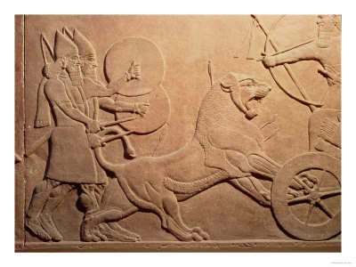 | Title:
 | Civilization:
 | Northern / Southern
 | Medium:
 | Date:
 | Misc:

4)
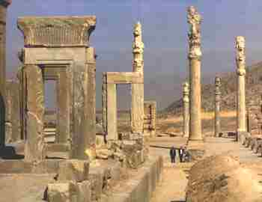 | Title:
 | Civilization:
 | Northern / Southern
 | Location:
 | Date:
 | Misc:

5)
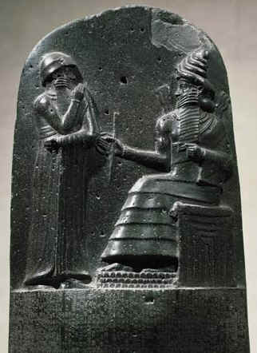 | Title:
 | Civilization:
 | Northern / Southern
 | Medium:
 | Date:
 | Misc:
PART III: Vocabulary (5 points)
Please fill-in the blanks with the correct answer.
1. ______________________ is a very shallow relief sculpture.
2. ______________________ is the “audience hall” in a Persian palace.
3. When a figure is depicted as being much bigger than other figures in the same scene, this is a demonstration of the ______________________ scale.
4. A lamassu is a winged human-headed bull, which is customary in ______________________ art.
5. A ______________________ is used to mark important sites, likes graves.

PART IV: Comparison (5 points)
Please compare and contrast the following two images.
What are their similarities and differences? Who is being depicted and why? What is the central reason for the creation of these two pieces of art? What do they say about each of the representative cultures and which civilizations are they from?
